**NAME-ADITYA ANANT AUNDHEKAR**

**ROLL NO-13**

**DIV-A**

**GR NO-11911050**

**FIR Digital Filter:A Case Study**

**CASE STUDY-1.1**

ABSTRACT-

This chapter discusses a case of a Finite Impulse Response (FIR) digital filter. Digital filtering is an important aspect of most DSP-oriented designs. This filter can be easily described using a behavioral coding style and the results of behavioral synthesis are easily understood.

1. INTRODUCTION

The chapter first discusses the filter function. It then discusses how the filter can be coded in a behavioral style and the synthesis issues that should be considered in order to produce a quality result

Filters are the most essential component used in signal processing and telecommunication systems. The main functions of a filter are to confine a signal into a prescribed frequency, to decompose a signal into two or more subband signals processing and modify the frequency spectrum of a signal.It then discusses how the filter can be coded in a behavioral style and the synthesis issues that should be considered in order to produce a quality result.The delays result in operating on prior input samples. The hk values are the coefficients used for multiplication, so that the output at time n is the summation of all the delayed samples multiplied by the appropriate coefficients.

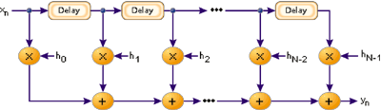

**The Algorithm-**

There are two general categories of digital filters: Finite Impulse Response (FIR) and Infinite Impulse Response (IIR). FIR filters can be implemented in a non-recursive manner and thus are stable. IIR filters are not always stable. A FIR filter is described by the following equation.

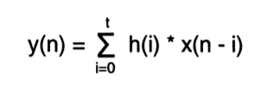

This equation defines the output of the filter as a function of previous input values. The variable t represents the number of previous input values that are used in the calculation of the output value. This value represents the number of taps associated with the filter. The filter described in this example has 15 taps. The variable x represents input data. The index associated with x indicates which sample of the input is being referred to. For example, xeD) is the current input data; x(1) is the previous input data, and so on. The variable h represents the tap coefficients that define the particular characteristics of the filter. These values are constant for a particular filter implementation.

There are 2 most primary types of the digital filter used in Digital Signal Processing (DSP) application which is Finite Impulse Response (FIR) and Infinite Impulse Response (IIR)[2]–[7]. There are several advantages of the digital filters compared to the analog filters in which digital filters’ performance does not vary with the environment[8]–[12]. Digital filters also can be operated at very low frequencies and have a wide range of frequencies by mere change to the sampling frequency. In this study, both FIR and IIR filters are designed to filter out the unwanted noise from the noise audio signal. IIR filter can be used when the only important requirements are sharp cutoff and high throughput, as it requires fewer coefficients than FIR filter. However, FIR filters should be used whenever a large number of filter coefficients and phase distortion is desired.

METHODOLOGY -

%get original audio file

[x,Fo] = audioread(**'G1o.wav'**);

%get time based

to=(1/Fo:1/Fo:length(x)/Fo);

%plot the Original Waveform in Time Domain

subplot(2,1,1);

plot(to,x);

grid;

title(**'Original Waveform in Time Domain'**);

xlabel(**'Time'**);ylabel(**'Amplitude'**);

%plot the Original Waveform in Frequency Domain

subplot (2,1,2);

m=length(x)-1;

fo=0:Fo/m:Fo;

%perform FFT for original waveform

xfft=abs(fft(x));

plot(fox fft);

grid;

title(**'Original Waveform in Frequency Domain'**);

xlabel(**'Frequency'**);ylabel(**'Magnitude'**);

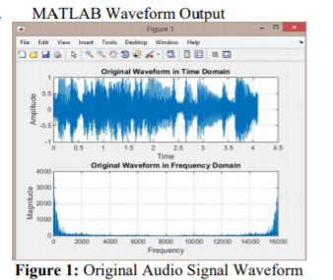

A. Noise Sound Analysis

i. MATLAB Programming Code

%get noise audio file

[y,Fn] = audioread(**'G1n.wav'**);

%get time based on sampling frequency for G1n.wav

tn=(1/Fn:1/Fn:length(y)/Fn);

%plot the Noise Waveform in Time Domain

subplot(2,1,2);

plot(tn,y);

grid;

title(**'Noise Waveform in Time Domain'**);

xlabel(**'Time'**);ylabel(**'Amplitude'**);

%plot the Noise Waveform in Frequency Domain

subplot(2,1,2);

n=length(y)-1;

fn=0:Fn/n:Fn;

%perform FFT noise waveform

fft=abs(fft(y));

plot(fn,yf ft);

grid;

title(**'Noise Waveform in Frequency Domain'**);

xlabel(**'Frequency'**);ylabel(**'Magnitude'**);

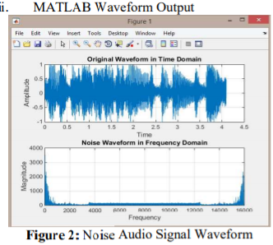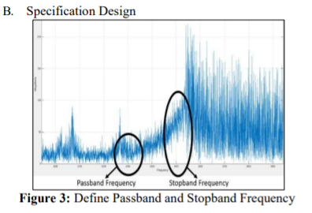

From observation of the original sound wave and noise sound wave, required specification for designing the digital filter as below

Sampling Frequency, = 16000Hz

Passband Frequency, = 3300Hz

Wp= 0.4125π

Stopband Frequency, = 3500Hz

wn== 0.4375π

Besides that, from the waveform, assumptions of several variables are defined.

Peak Passband Deviation,ap= 1dB

Stopband Deviation, = 50

Minimum Stopband Deviation, = 34 dB

C. FIR Filter Design

Design Calculation From the observation, the minimum stopband deviation was 34dB. Therefore, the Hanning window is chosen as the value obtained was the nearest with less than 44dB.

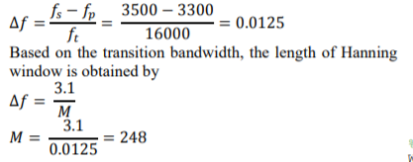

%filter design

fs = 3500; %stopband frequency

fp = 3300; %passband frequency

ft = 16000; %sampling frequency

Wn = (fs+fp)/ft;

%Window-based fir filter design

a = fir1(248,Wn,hann(Wn));

%plot the frequency response

freqz(a,1);

figure(2);

%plot the low pass filter

plot(w/pi, 20*log10(abs(h)));

title(**'Low Pass Filter'**);

xlabel(**'\omega/\pi'**);ylabel(**'Gain (dB)'**);

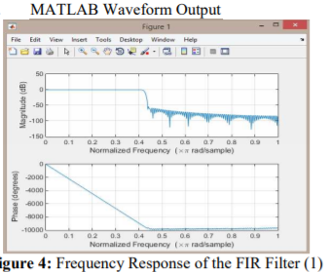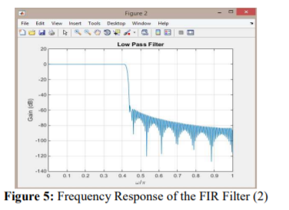

A. FIR Filter Design

i. MATLAB Coding

%get original audio file

[x,Fo] = audioread(**'G1o.wav'**);

%get time based on sampling frequency for G10.wav

to=(1/Fo:1/Fo:length(x)/Fo);

%get noise audio file

[y,Fn] = audioread(**'G1n.wav'**);

%get time based on sampling frequency for G1n.wav

tn=(1/Fn:1/Fn:length(y)/Fn);

figure(1);

%plot the Original Waveform in Time Domain

subplot(2,1,1);

plot(to,x);

grid;

title(**'Original Waveform in Time Domain'**);

xlabel(**'Time'**);ylabel(**'Amplitude'**);

%plot the Original Waveform in Frequency Domain

subplot (2,1,2);

m=length(x)-1;

fo=0:Fo/m:Fo;

%perform FFT for original waveform

xfft=abs(fft(x));

plot(fox fft);

grid;

title(**'Original Waveform in Frequency Domain'**);

xlabel(**'Frequency'**);ylabel(**'Magnitude'**);

figure(2);

%plot the Noise Waveform in Time Domain

subplot(2,1,1);

plot(tn,y);

grid;

title(**'Noise Waveform in Time Domain'**);

xlabel(**'Time'**);ylabel(**'Amplitude'**);

%plot the Noise Waveform in Frequency Domain

subplot(2,1,2);

n=length(y)-1;

fn=0:Fn/n:Fn;

%perform FFT noise waveform

fft=abs(fft(y));

plot(fn,yf ft);

grid;

title(**'Noise Waveform in Frequency Domain'**);

xlabel(**'Frequency'**);ylabel(**'Magnitude'**);

%filter design

fs = 3500; %stopband frequency

fp = 3300; %passband frequency

ft = 16000; %sampling frequency

Wn = (fs+fp)/ft;

%Window-based fir filter design

a = fir1(248,Wn);

%Frequency response of digital filter

[h,w] = freqz(a,1);

z = filter(a,1,y);

%filter the noise data, y

%write the filtered sound

audiowrite(**'Filtered_FIR_G1.wav'**,z,ft);

%get the filtered audio file

[n,Ff]=audioread(**'Filtered_FIR_G1.wav'**);

%get time based

tf=(1/Ff:1/Ff:length(n)/Ff);

figure(3);

%plot the waveform in time domain

subplot(2,1,1);

plot(tf,n);

grid;

title(**'Filtered Waveform in Time Domain'**);

xlabel(**'Time'**);ylabel(**'Amplitude'**);

subplot (2,1,2);

%plot the waveform in frequency domain

m=length(n)-1;

ff=0:Ff/m:Ff;

nfft=abs(fft(n)); %perform fft

plot(ff,nfft);

Grid;

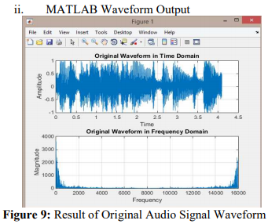

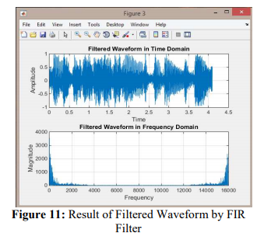

**CASE STUDY-1.2-RADIO ASTRONOMY**

The correlation between the far-infrared (FIR) and radio emission is well established for nearby star forming galaxies. Many applications, in particular the radio-to-submm spectral index redshift indicator, tacitly assume that the relation holds well beyond our local neighbourhood, to systems located at cosmological distances. In order to test this assumption I have constructed a sample of 20 HDF-N galaxies, all with measured spectroscopic redshifts, and all detected by *both* ISO and the WSRT at 15 micron and 1.4 GHz respectively. The galaxies span a wide range of redshift with a median value of . The ISO 15 micron data were k-corrected and extrapolated to the FIR (60 and 100 micron) by assuming a starburst (M 82) spectral energy distribution (SED) for the entire sample. An initial analysis of the data suggests that the correlation between the FIR and the radio emission continues to apply at high redshift with no obvious indication that it fails to apply beyond . The sample is “contaminated” by at least 1 distant (), radio-loud AGN, VLA J123642+621331. This source has recently been detected by the first deep field VLBI observations of the HDF-N and is clearly identified as an outlier in the FIR/radio correlation.

**METHODOLOGY-**

A radio telescope tracks radiation from celestial sources. The combination of a reflector and a feed converts the incident electromagnetic radiation to an electrical signal. The signal received by the telescope is fed to a low noise amplifier. An isolator prevents reflection of the signal, which could otherwise result in the reradiation of signal power and eventual interference effects. The signal is then boosted by 30-dB. This is followed by a filter, which limits the signal to the frequency range of interest. Since the signal frequencies are very high, it would be convenient to have the signal frequency converted to a convenient intermediate frequency, as hardware is easier to build at lower frequencies. Heterodyning technique is used for down conversion. Heterodyning has the advantage of providing tunability over a wide range. Also, much of the required electronics is independent of the radio frequencies. The master oscillator is a Rubidium oscillator, which is a very stable oscillator and provides the reference for the synthesizer. The synthesizer is tunable and provides the local oscillator signal required for heterodyning. The signal frequency obtained from the synthesizer is multiplied by a factor of 48. The signal from the local oscillator and the signal from the source are multiplexed and the IF signal brought down to an intermediate frequency of 1450MHz. The intermediate frequency is always maintained at 1450MHz irrespective of the source being observed. This is done by suitably tuning the synthesizer. The subsequent bandpass filter has a center frequency of 1450MHz and a bandwidth of 20MHz. An amplifier with a gain factor of 29dB follows the filter

**CASE STUDY 3-EEG (MEDICAL)-**

**INTRODUCTION-**

Filters play a role in applications such as speech processing, image processing, echo cancellation, noise cancellation, software defined radio etc. filters are basically classified into analog and digital. In this paper a digital filter is used. These are further classified into IIR and FIR filters. Many applications require FIR Filter in order to meet frequency specifications. FIR filters have an advantage over infinite impulse response (IIR) as they are easy to design and support high sampling rate. The number of multiplication and addition operations increases as the filter order increases. FIR filters can be made linear phase by making filter coefficients symmetrical where quantized values of impulse response of frequency transfer H(f) is h(n) in FIR filter . These remain constant and are known priori in signal processing applications.

EEG contains four different types of signals alpha, beta, delta and theta ranging from 8-14Hz, 14-50Hz, 0.5-14Hz and 14-50Hz respectively. Signals ranging out of these are treated as noises or artifacts. These can be from eye blinks, motion artifacts, impedance of wires etc. Therefore, to remove the noise content of signal, in [7] Lab-View platform is used for epileptic seizure detection using statistical analysis

Many researchers have suggested different design styles for filters by making use of Distributed Arithmetic (DA) and MCM methods. DA based designs utilize look up tables to store values, thereby reducing design complexity. The MCM technique reduces the number of additional steps in multiplication operations. This method is more suitable for FIR filter designing and implementation. These can be implemented in transpose form but not in direct form configuration of FIR filters. Another way that is popular is block processing which gives higher throughput. The areadelay efficiency is also improved in this. Block processing is straightforward. When direct form configuration of FIR filter is derived. In transpose form block processing is not supported directly. In order to make FIR filters more efficient, advantages of both MCM and Block processing are combined. It is realized in transpose form as they have pipelining nature and provide high operating frequency in order to support higher sampling rate and block processing for higher throughOUT.

METHODOLOGY AND APPLICATION-

Chen and Chiueh [1] have proposed a reconfigurable FIR filter (RFIR) where a non-zero canonic signed digit values are modified to reduce precision of filter coefficients without significant impact on filter behaviour. This design is not area delay efficient. The architecture suits only lower order filter. Constant shift method and programmable shift method has been proposed in [2] for RFIR for SDR channelizer. The SDR channelizer need reconfigurable FIR filter in order to support multi strand wireless communication. Sang Yoon Park et al. [3] proposed an efficient distributed arithmetic (DA) based approach for high throughput reconfigurable implementation of finite impulse response (FIR) filters. The filter coefficients change during runtime. J. Park, et al. presented [5] a programmable digital finite impulse response (FIR) filter for high-performance and low-power applications. The architecture can be used in low complexity programmable FIR filter design. It is based on a computation sharing multiplier (CSHM) which targets computation re-use in vector-scalar products. In some multiplier based structure either transpose or direct form is used. DA based architecture used direct form and multiplier less based architecture used transpose form. Block based filters are inefficient for large filter length and variable coefficients. They are suitable only for 2D filters and block least mean square (BLMS). In this work MCM technique and pipelining is used for area delay efficiency to realise large order FIR filter for both fixed and reconfigurable application. EEG signals contain artifacts (noise) along with required data signals of the brain. These noises can be filtered using different filters like high pass, low pass, band-pass, etc depending on the requirement of actual data. Different diseases like sleep disorders, epilepsy, seizures etc can be detected through EEG signals. Various artifacts such as PLI (Power line interference), MA (Muscle artifact), and EBA (Eye blink artifact) are present during recording the EEG.

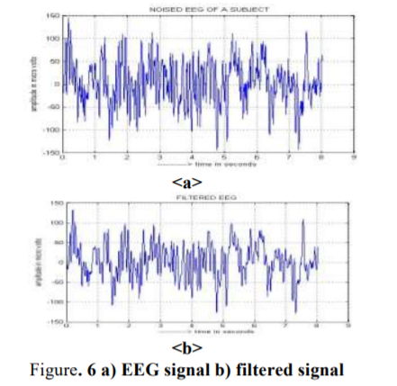

**CONCLUSION-**

At the end of this study, the digital audio signals could be recognized in both time domain and frequency domain waveform. By comparing the frequency domain waveform, the unwanted noise signal can be recognized. The entire unwanted noise signal has been filtered by using FIR and IIR filter.

The FIR filter The problem of radiation is a key issue in Space applications, since it produces several negative effects on digital circuits. However, traditional protection techniques against soft errors, like Triple Modular Redundancy (TMR) or EDAC codes (for example Hamming), normally result in a significant area and power overhead. In this paper we propose a specific technique to protect digital finite impulse response (FIR) filters applying the ''system knowledge''

**References-**

[1] S. K. Mitra, Digital Signal Processing: A Computer-Based Approach, Fourth. Mc-GrawHill, 2011.

[2].<https://link.springer.com/chapter/10.1007/978-1-4615-5059-4_15>

[3]<http://urregoj.pbworks.com/w/file/fetch/69508144/JulianUrrego_FIR_CaseStudy.pdf>

[4]<https://www.researchgate.net/publication/220686685_Protection_against_soft_errors_in_the_space_environment_A_finite_impulse_response_FIR_filter_case_study>

[5] <http://dspace.rri.res.in/bitstream/2289/6034/1/Anupama_Ashwini_Soumya.pdf>

………………………………………………………………………………………………………………………………………………………………………...